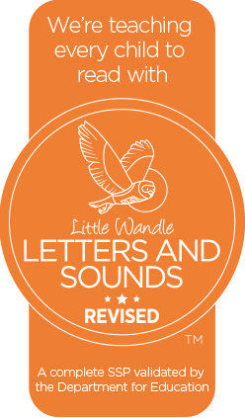
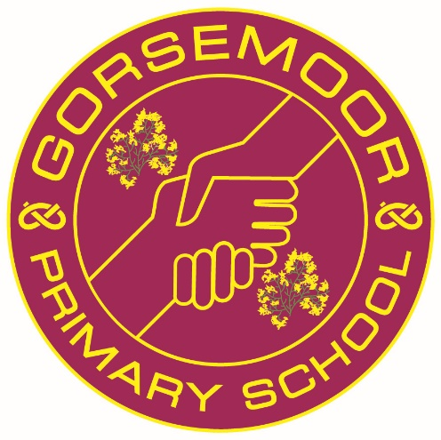

Growing together, hand in hand

Phonics Policy

Last Updated March 2023
Audience: Staff/Governors/Public
Frequency of Review: Annually
Post-holder responsible for Review: Phonics Lead

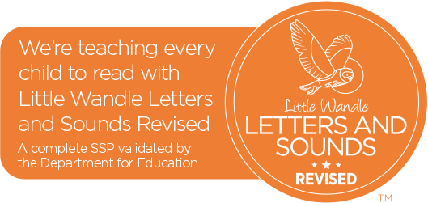
Recommended associated documents:
Reading Policy

The context of our school
At Gorsemoor Primary School, high-quality teaching and learning is at the forefront of our approach. We are dedicated to ensuring that all our children, irrespective of their background or the challenges they face, achieve their full potential. We embrace our children’s individuality and nurture their academic, social and emotional growth. Our aim is to provide a consistent approach to teaching phonics and reading that is accessible to all learners; supporting them to access all areas of our curriculum.
Vision
It is our belief, that the purpose of education is to provide young people with the knowledge and skills to prepare children for their diverse working lives, build character, teach knowledge for its own intrinsic value and ignite a love of learning. Phonics opens our eyes to seeing the meaning of symbols, co-ordinating letters with sounds, and then helps us to tie these together to form words. We believe learning phonics is the crucial starting point that builds children into readers and it is therefore a vital skill to ensure the development of independent, engaged and efficient learners.
Intent
Phonics (reading and spelling)
At Gorsemoor Primary School, we believe that all our children can become fluent readers and writers. This is why we teach reading through Little Wandle Letters and Sounds Revised, which is a systematic and synthetic phonics programme. We start teaching phonics in Nursery/Reception and follow the Little Wandle Letters and Sounds Revised progression, which ensures children build on their growing knowledge of the alphabetic code, mastering phonics to read and spell as they move through school.
As a result, all our children are able to tackle any unfamiliar words as they read. At Gorsemoor Primary School, we also model the application of the alphabetic code through phonics in shared reading and writing, both inside and outside of the phonics lesson and across the curriculum. We have a strong focus on language development for our children because we know that speaking and listening are crucial skills for reading and writing in all subjects.
Comprehension
At Gorsemoor Primary School, we value reading as a crucial life skill. By the time children leave us in Year 6, they read confidently for meaning and regularly enjoy reading for pleasure. Our readers are equipped with the tools to tackle unfamiliar vocabulary. We encourage our children to see themselves as readers for both pleasure and purpose.
Because we believe teaching every child to read is so important, we have a Reading Leader who drives the early reading programme in our school. This person is highly skilled at teaching phonics and reading, and they monitor and support our reading team, to ensure everyone teaches with fidelity to the Little Wandle Letters and Sounds Revised programme.
Implementation
Foundations for phonics in Nursery
- We provide a balance of child-led and adult-led experiences for all children that meet the curriculum expectations for ‘Communication and language’ and ‘Literacy’. These include:
  - sharing high-quality stories and poems
  - learning a range of nursery rhymes and action rhymes
  - activities that develop focused listening and attention, including oral blending
  - attention to high-quality language.
- We ensure Nursery children are well prepared to begin learning grapheme-phoneme correspondences (GPCs) and blending in Reception.

Daily phonics lessons in Reception and Year 1
- We teach phonics for 30 minutes a day. In Reception, we build from 10-minute lessons, with additional daily oral blending games, to the full-length lesson as quickly as possible. Each Friday, we review the week’s teaching to help children become fluent readers.
- Children make a strong start in Reception: teaching begins in Week 2 of the Autumn term.
- We follow the Little Wandle Letters and Sounds Revised expectations of progress:
  - Children in Reception are taught to read and spell words using Phase 2 and 3 GPCs, and words with adjacent consonants (Phase 4) with fluency and accuracy.
  - Children in Year 1 review Phases 3 and 4 and are taught to read and spell words using Phase 5 GPCs with fluency and accuracy.
Resources have been carefully been selected and ordered from Harper Collins to ensure fluency and consistency across the year groups within Phase 1. Children in Years 1 and 2 have a Phonics exercise book in which to record evidence of their practice and application tasks. Individual mini whiteboards are also frequently used across all our Early Years Foundation Stage, Year 1 and Year 2 when practising within the lesson.
Age related expectations for the end of the year
Little Wandle Letters and Sounds Revised programme overview shows the progression of GPCs and tricky words that we teach term-by-term. The progression has been organised so that children are taught from the simple to more complex GPCs, as well as considering the frequency of their occurrence in the most commonly encountered words. All the graphemes taught are practised in words, sentences, and later on, in fully decodable books. Children review and revise GPCs and words, daily, weekly and across terms and years, in order to move this knowledge into their long-term memory. Children need to learn to read as quickly as reasonably possible, so they can move from learning to read, to reading to learn, giving them access to the treasure house of reading. Our expectations of progression are aspirational yet achievable if we maintain pace, practice and participation with all children.
- In Reception the children should be able to read and understand simple sentences. They should use their phonic knowledge to decode regular words and read them aloud accurately. They should also read some common irregular words and demonstrate an understanding when talking with others about what they have read. (See appendix 1 for more detail).
- In Year 1 the children should be able to apply their phonic knowledge and skills to blend and accurately read unfamiliar words containing the taught GPCs. The children should respond speedily with the correct sound to grapheme for all 40+ phonemes, including alternative sounds for graphemes. (See appendix 2). They should be reading frequently to build on their fluency and comprehension skills. Children should be able to read and spell the given Year 1 common exception words. The children in Year 1 should also be able to write from memory simple sentences that have been dictated by the teacher, including words using the GPCs and common exception words taught.
Daily Keep-up lessons ensure every child learns to read
- Any child who needs additional practice has daily Keep-up support, taught by a fully trained adult. Keep-up lessons match the structure of class teaching, and use the same procedures, resources and mantras, but in smaller steps with more repetition, so that every child secures their learning.
- We timetable daily phonics and spelling lessons for any child in Year 2 and above who is not fully fluent at reading or has not passed the Phonics screening check. These children urgently need to catch up, so the gap between themselves and their peers does not widen. We use the Rapid Catch-up assessments to identify the gaps in their phonic knowledge and teach to these using the Rapid Catch-up resources – at pace.
- These short, sharp lessons last 15-20 minutes daily and have been designed to ensure children quickly catch up to age-related expectations in reading.

Teaching reading: Reading practice sessions three times a week
- We teach children to read through reading practice sessions three times a week. These:
  - are taught by a fully trained adult to small groups of approximately six children
  - use books matched to the children’s secure phonic knowledge using the Little Wandle Letters and Sounds Revised assessments and book matching grids on pages 11–20 of ‘Application of phonics to reading’.
  - are monitored by the class teacher, who rotates and works with each group on a regular basis.
- Each reading practice session has a clear focus, so that the demands of the session do not overload the children’s working memory. The reading practice sessions have been designed to focus on three key reading skills:
  - decoding
  - prosody: teaching children to read with understanding and expression
  - comprehension: teaching children to understand the text.
- In Reception these sessions start in Week 4. Children who are not yet decoding have daily additional blending practice in small groups, so that they quickly learn to blend and can begin to read books.
- In Year 2, we continue to teach reading in this way for any children who still need to practise reading with decodable books.

Home reading
- The decodable reading practice book is taken home to ensure success is shared with the family.
  - Reading for pleasure books, from our Gorsemoor school library, also go home for parents to share and read with children.
  - We use the Little Wandle Letters and Sounds Revised parents’ resources to engage our families and share information about phonics, the benefits of sharing books, how children learn to blend and other aspects of our provision, both online and through workshops.

Resources to support teaching and delivery
Within every Phonics lesson the children have access to flashcards, word cards and tricky words. All teaching staff follow a continuous structure to each lesson starting with revisiting prior teaching to learning to a new GPC and then reading words with the new sound included. (See appendix 3 for examples).
Reading practice sessions include a new Collins Big Cat Phonics decodable reading book. Within each reading practice session, the resources that are used are GPCs, read the words, vocabulary and tricky word cards to read within the small group.
Additional reading support for vulnerable children
- Children in Reception and Year 1 who are receiving additional phonics keep-up sessions read their reading practice book to an adult - at least three times per week - and have the opportunity to read this book daily.

Ensuring reading for pleasure
‘Reading for pleasure is the single most important indicator of a child’s success.’ (OECD 2002)
‘The will influences the skill and vice versa.’ (OECD 2010)
We value reading for pleasure highly and work hard as a school to grow our Reading for Pleasure pedagogy.
- We read to children every day. We choose these books carefully as we want children to experience a wide range of books, including books that reflect the children at Gorsemoor Primary School, and our local community as well as books that open windows into other worlds and cultures.
- Every classroom has a reading space that supports and encourages a love for reading. We curate these books and talk about them to entice children to read a wide range of books.
- In Nursery/Reception, children have access to their reading space every day in their free flow time and the books are continually refreshed.
- Each class regular visits our school library throughout the half term. We also aim for the children to visit our local community library in their classes to engage with a wider range of reading for pleasure books and authors.
- Children across the school have regular opportunities to engage with a wide range of Reading for Pleasure events (book fairs, author visits and workshops, national events etc).

Teaching and learning
At Gorsemoor, we believe that phonics should not only just be taught during a 30-minute lesson and within reading practice sessions, but that phonics should be embedded across all curriculum areas. We strive to provide the children with the confidence and ability to use the phonetic knowledge within all curriculum subjects, beyond the scheme’s expectations. Across both Early Years and Phase 1, the children have further opportunities throughout the day to practise and consolidate their knowledge and build upon their skills within the areas of provision. Our provision within school is high-quality, and the skilled practitioners ensure that there are no opportunities for misconceptions to arise within the classroom. This meaning, that activities and tasks are modelled correctly to ensure that all children are aware of how to pronounce, consolidate and support their own learning independently.
The children are given opportunities to access the scheme through a variety of multi-modal approaches. This is to support the children in retaining and building on their phonic knowledge in a manner that is accessible to them.
The children in both Reception and Year 1 will learn a variety common exception words. These words are taught to the children exploring the word in depth and looking for the section of the word that is ‘tricky’. All practitioners address misconceptions regularly to the children to ensure that they remember that these are words that we are unable to decode.
Impact
Assessment
Assessment is used to monitor progress and to identify any child needing additional support as soon as they need it. At Gorsemoor in Phase 1, we use Phonics Tracker as our summative assessment tool to support staff and to ensure all data is in one accessible space to monitor and identify any additional support that may be needed for our children.

- Assessment for learning is used:
  - daily within class to identify children needing keep-up support
  - weekly in the review lesson to assess gaps, address these immediately and secure fluency of GPCs, words and spellings.

- Summative assessment for Reception and Year 1 is used:
  - every six weeks to assess progress, to identify gaps in learning that need to be addressed, to identify any children needing additional support and to plan the keep-up support that they need.
  - by SLT and scrutinised through the Little Wandle Letters and Sounds Revised assessment tracker, to narrow attainment gaps between different groups of children and so that any additional support for teachers can be put into place.

- Fluency assessments measure children’s accuracy and reading speed in short one-minute assessments. They are used:
- in Year 1, when children are reading the Phase 5 set 3, 4 and 5 books
- with children following the Rapid Catch-up programme in Years 2 to 6, when they are reading the Phase 5 set 3, 4 and 5 books
- to assess when children are ready to exit their programme. For Year 1 children, this is when they read the final fluency assessment at 60–70+ words per minute. Older children can exit the Rapid Catch-up programme when they read the final fluency assessment at 90+ words per minute. At these levels, children should have sufficient fluency to tackle any book at age-related expectations. After exiting their programme, children do not need to ready any more fully decodable books.

- A placement assessment is used:
  - with any child new to the school in Reception and Year 1 to quickly identify any gaps in their phonic knowledge and plan and provide appropriate additional teaching.

- The Rapid Catch-up assessment is used
  - with any child new to the school in Year 2 and above to quickly identify any gaps in their phonic knowledge and plan and provide appropriate additional teaching. This will all be recorded on Phonics Tracker along with all other Phonics data.

Statutory assessment
- Children in Year 1 sit the Phonics screening check. Any child not passing the check
re-sits it in Year 2.
- Included in the phonics screening check are a selection of both real and pseudo ‘alien’ words. Children are regularly exposed to both real and ‘alien’ words to promote familiarity with the phonics screening paper. These are shown to the children on flashcards, practical activities, whiteboard flipcharts and on teacher lanyards, all during our daily lessons.
- A meeting is held in the Spring Term to inform parents about the phonics screening and to give details of how it is administered. Parents are able to see example papers and gain advice on how to support their children in revising and applying their phonic knowledge. Parents also receive an information booklet of frequently asked questions relating to the screening.
- There are strict guidelines which we must adhere to when administering the screening. To ensure the children are fully prepared, these guidelines and any recommended dialogue, is used with the children during all practise screenings. This ensures the whole process is familiar to the children.
Ongoing assessment for Rapid Catch-up in Year 2
- Children in Year 2 who are still completing Phonics are assessed through:
  - the Rapid Catch-up initial assessment to quickly identify any gaps in their phonic knowledge and plan appropriate teaching
  - the Rapid Catch-up summative assessments to assess progress and inform teaching
  - the Rapid Catch-up fluency assessments when children are reading the Phase 5 set 3, 4 and 5 books for age 7+.
- The fluency assessments measure children’s accuracy and reading speed in short
one-minute assessments. They also assess when children are ready to exit the Rapid Catch-up programme, which is when they read the final fluency assessment at 90+ words per minute.

Appendices
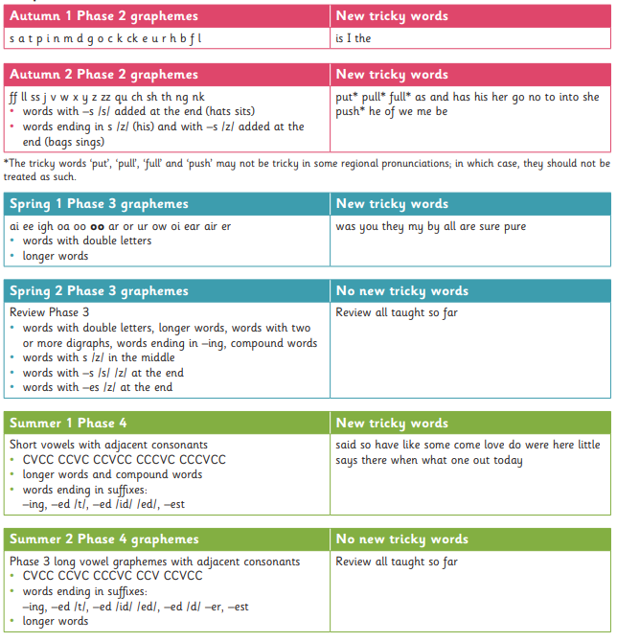
Appendix 1

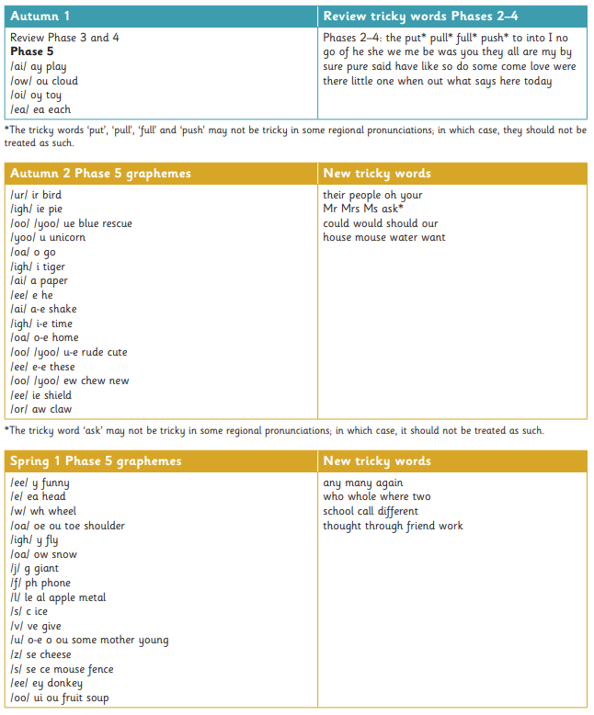
Appendix 2

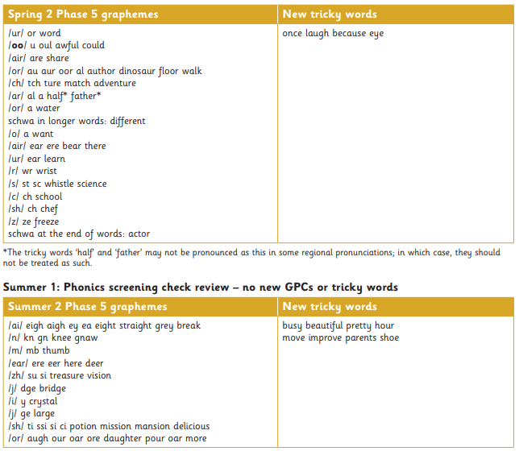

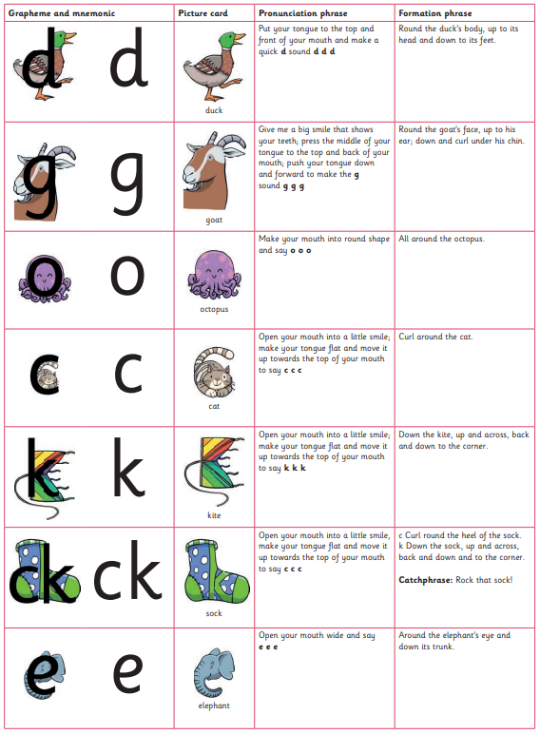
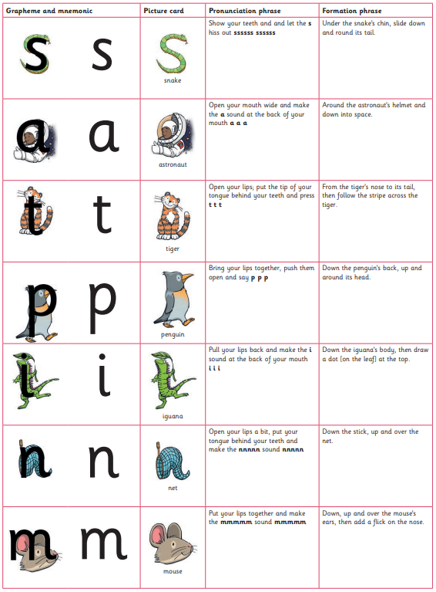
Appendix 4 – Resource Inventory
Reception Autumn Sounds

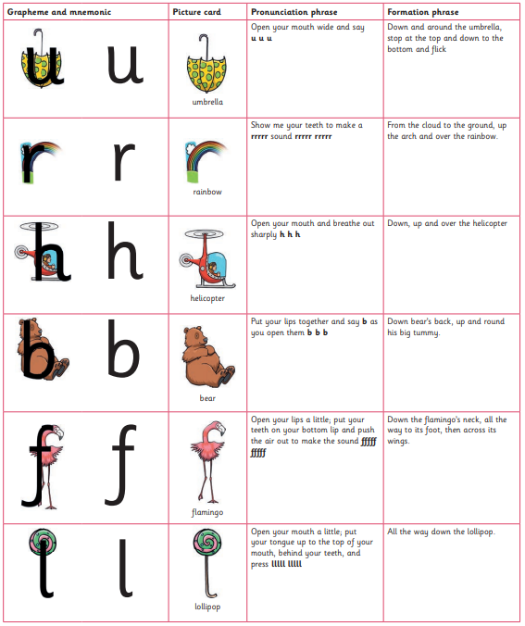
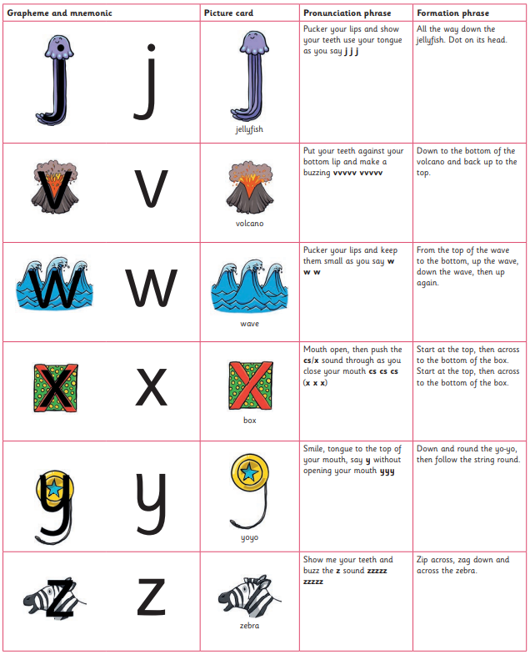

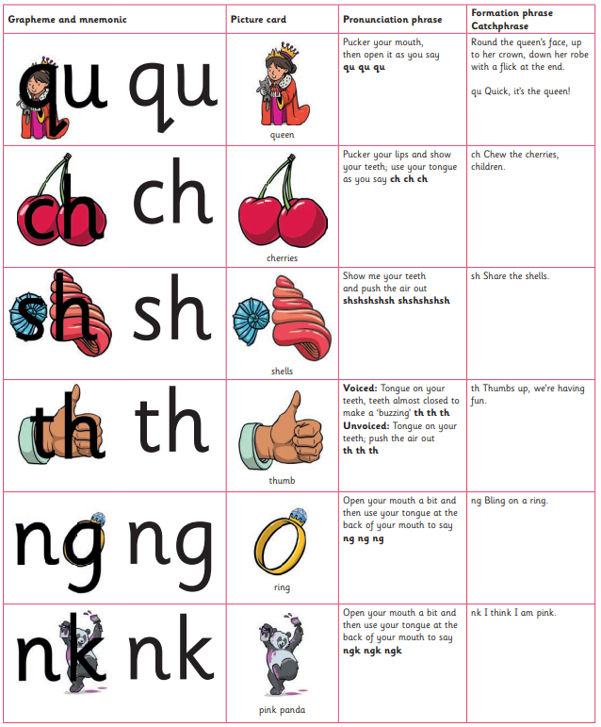

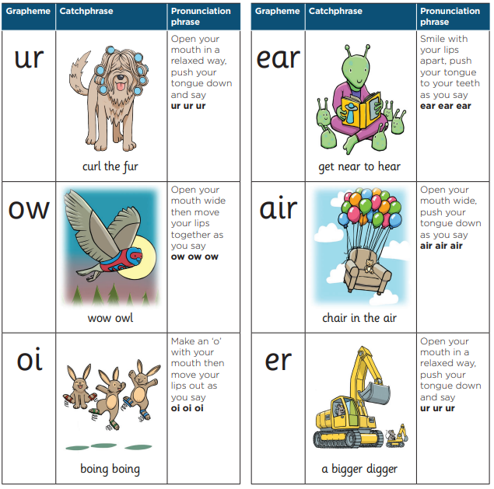
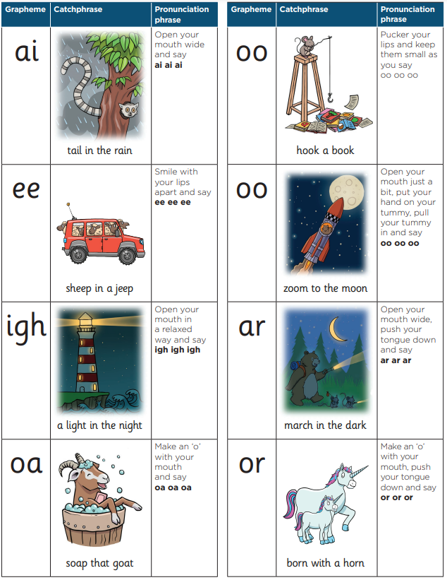
Reception Spring Sounds

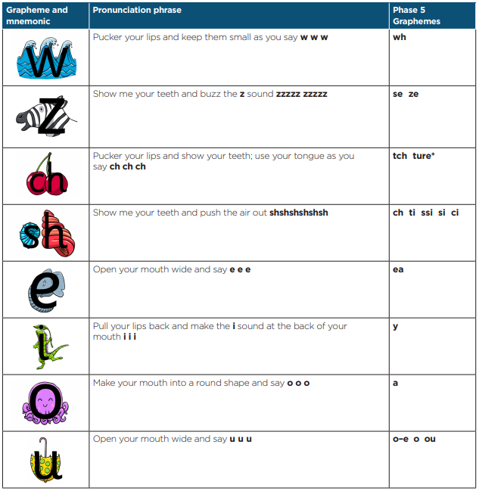
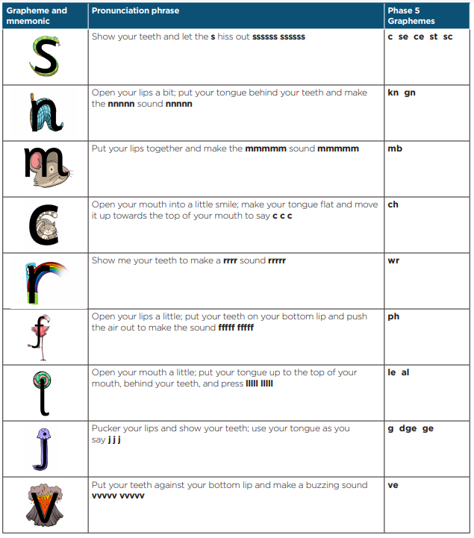
Year 1 Sounds (alternative graphemes)



